Analysis of multi-story multi-bay RC plane frame
Input data
Number of stories - $n_{st}=5$ , Number of bays - $n_{b}=3$
Story height - $h_{st}=2.85 \text{m}$, Bay length- $l_{b}=4\text{ m}$
Slab thickness - $h_{pl}=18\text{ cm}$
Cross section of columns - $b_{c}=25 \text{cm}$ , $h_{c}=60\text{ cm}$
Cross section of beams - $b_{b}=25 \text{cm}$ , $h_{b}=40\text{ cm}$
Joint coordinates - $n_{J}=24$
${\vec{x}}_{J}=\left[0 4 8 12 0 4 8 12 0 4 ... 12\right]\text{ m}$, ${\vec{y}}_{J}=\left[0 0 0 0 2.85 2.85 2.85 2.85 5.7 5.7 ... 14.25\right]\text{ m}$
Elements - [J1; J2] - $n_{E}=35$
$$\text{transp}\left(e_{J}\right)=\left[\begin{matrix}1 & 2 & 3 & 4 & 5 & 6 & 7 & 8 & 9 & 10 & ⋯ & 23 \\ 5 & 6 & 7 & 8 & 9 & 10 & 11 & 12 & 13 & 14 & ⋯ & 24\end{matrix}\right]$$
Element endpoint coordinates
$x_{1}\left(e\right)={{\vec{x}}_{J}}_{.{e_{J}}_{e,1}}$ , $y_{1}\left(e\right)={{\vec{y}}_{J}}_{.{e_{J}}_{e,1}}$ , $x_{2}\left(e\right)={{\vec{x}}_{J}}_{.{e_{J}}_{e,2}}$ , $y_{2}\left(e\right)={{\vec{y}}_{J}}_{.{e_{J}}_{e,2}}$
Element length - $l\left(e\right)=\sqrt{{\left(x_{2}\left(e\right)-x_{1}\left(e\right)\right)}^{2}+{\left(y_{2}\left(e\right)-y_{1}\left(e\right)\right)}^{2}}$
Element direction - $c\left(e\right)=\frac{x_{2}\left(e\right)-x_{1}\left(e\right)}{l\left(e\right)}$ , $s\left(e\right)=\frac{y_{2}\left(e\right)-y_{1}\left(e\right)}{l\left(e\right)}$
Transformation matrix
Diagonal 3x3 block - $t\left(e\right)=\text{hp}\left(\left[c\left(e\right);s\left(e\right);0 | \text{-}s\left(e\right);c\left(e\right);0 | 0;0;1\right]\right)$
Generation of the full transformation matrix
$$T\left(e\right)=\text{add}\left(t\left(e\right);\text{add}\left(t\left(e\right);\text{matrix}\left(6;6\right);1;1\right);4;4\right)$$
Supports - $n_{c}=4$
$$c=\left[\begin{matrix}1 & {10}^{20}\text{ kN}/\text{ m} & {10}^{20}\text{ kN}/\text{ m} & 0\text{ kNm} \\ 2 & {10}^{20}\text{ kN}/\text{ m} & {10}^{20}\text{ kN}/\text{ m} & 0\text{ kNm} \\ 3 & {10}^{20}\text{ kN}/\text{ m} & {10}^{20}\text{ kN}/\text{ m} & 0\text{ kNm} \\ 4 & {10}^{20}\text{ kN}/\text{ m} & {10}^{20}\text{ kN}/\text{ m} & 0\text{ kNm}\end{matrix}\right]$$
Unit weights of building materials
- concrete - $γ_{c}=25\text{ kN}/{\text{ m}}^{3}$ - screed - $γ_{scr}=21\text{ kN}/{\text{ m}}^{3}$
- finishes - $γ_{fin}=18\text{ kN}/{\text{ m}}^{3}$ - brickwork - $γ_{bw}=16\text{ kN}/{\text{ m}}^{3}$
- plaster/render - $γ_{pla}=16\text{ kN}/{\text{ m}}^{3}$ - insulation - $γ_{ins}=0.5\text{ kN}/{\text{ m}}^{3}$
Loads
Total halfwidth of adjacent plate spans - $a=\frac{5\text{ m}}{2}=2.5\text{ m}$
Self weight
Plate - $g_{pl}=h_{pl}·a·γ_{c}=11.25\text{ kN}/\text{ m}$
Beam - $g_{b}=b_{b}·\left(h_{b}-h_{pl}\right)·γ_{c}=1.38\text{ kN}/\text{ m}$
Total for beam - $sw=g_{pl}+g_{b}=12.62\text{ kN}/\text{ m}$
Column - $g_{c}=b_{c}·h_{c}·γ_{c}=3.75\text{ kN}/\text{ m}$
Dead loads
Screed - $g_{scr}=8\text{ cm}·a·γ_{scr}=4.2\text{ kN}/\text{ m}$
Finishes - $g_{fin}=2\text{ cm}·a·γ_{fin}=0.9\text{ kN}/\text{ m}$
Plaster ceiling - $g_{pls}=2\text{ cm}·a·γ_{pla}=0.8\text{ kN}/\text{ m}$
Brick wall - $g_{bw}=25\text{ cm}·\left(h_{st}-h_{b}\right)·γ_{bw}=9.8\text{ kN}/\text{ m}$
Wall insulation - $g_{ins}=15\text{ cm}·h_{st}·γ_{ins}=0.214\text{ kN}/\text{ m}$
Wall plaster/render - $g_{plw}=2·2\text{ cm}·h_{st}·γ_{pla}=1.82\text{ kN}/\text{ m}$
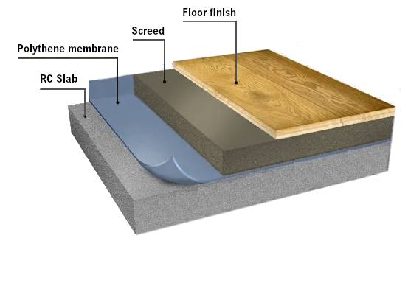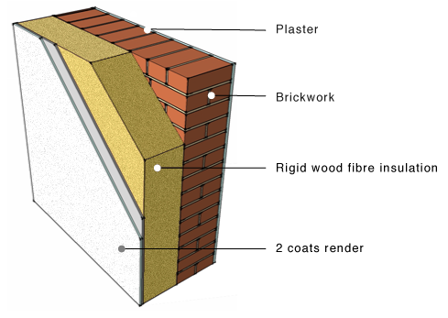
Total dead load
$$dl=g_{scr}+g_{fin}+g_{pls}+g_{bw}+g_{ins}+g_{plw}=17.74\text{ kN}/\text{ m}$$
Live load - $ll=a·2\frac{\text{ kN}}{{\text{ m}}^{2}}=5\text{ kN}/\text{ m}$
Total load
On beams - $p_{b}=\left(sw+dl\right)·1.35+ll·1.5=48.49\text{ kN}/\text{ m}$
On columns - $p_{c}=g_{c}·1.35=5.06\text{ kN}/\text{ m}$
Load values on elements
$${\vec{q}}_{x}=\left[0 0 0 0 0 0 0 0 0 0 ... 0\right]\text{ kN}/\text{ m}$$
$${\vec{q}}_{y}=\left[\text{-}5.06 \text{-}5.06 \text{-}5.06 \text{-}5.06 \text{-}5.06 \text{-}5.06 \text{-}5.06 \text{-}5.06 \text{-}5.06 \text{-}5.06 ... \text{-}48.49\right]\text{ kN}/\text{ m}$$
Scheme of the structure
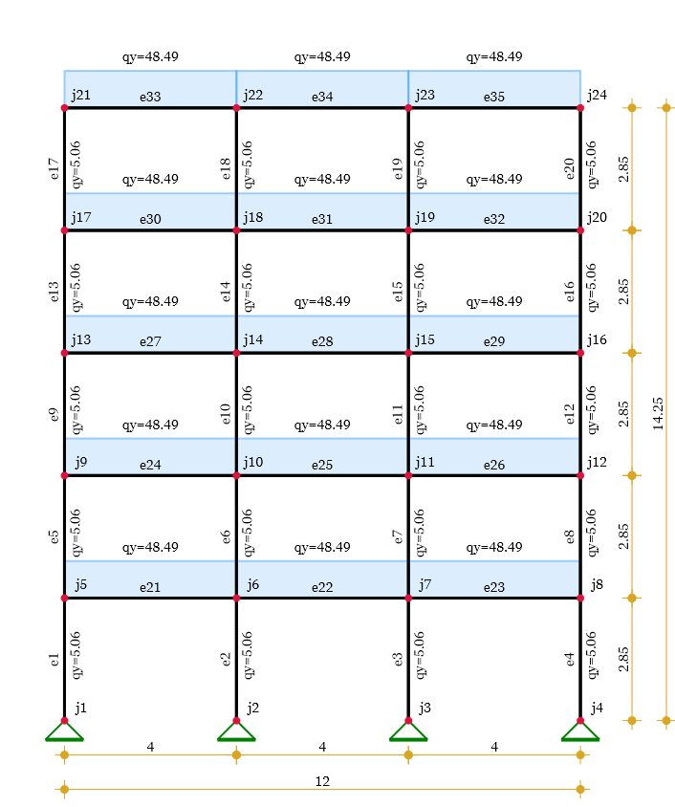
Materials
Modules of elasticity - $\vec{E}=\text{hp}\left(\left[35\text{ GPa}\right]\right)=\left[35\right]\text{ GPa}$
Poisson coefficients - $\vec{ν}=\text{hp}\left(\left[0.2\right]\right)=\left[0.2\right]$
Shear modules - $\vec{G}=\frac{\vec{E}}{2·\left(1+\vec{ν}\right)}=\left[14.58\right]\text{ GPa}$
Assignments on elements
$${\vec{e}}_{M}=\text{fill}\left({\text{vector}}_{hp}\left(n_{E}\right);1\right)=\left[1 1 1 1 1 1 1 1 1 1 ... 1\right]$$
Cross sections
Calculation of effective flange width
$$l_{0}=0.85·l_{b}=3.4\text{ m}$$
$$b_{eff}=b_{b}+\text{min}\left(0.2·a+0.1·l_{0};0.2·l_{0}\right)=93\text{ cm}$$
Section 1 - ${\vec{b}}_{1}=b_{c}=25 \text{cm}$ , ${\vec{h}}_{1}=h_{c}=60\text{ cm}$ - columns
Section 2 - ${\vec{b}}_{2}=b_{b}=25 \text{cm}$ , ${\vec{h}}_{2}=h_{b}=40 \text{cm}$ - beams
${{\vec{b}}_{f}}_{.}=b_{eff}=93\text{ cm}$ , ${{\vec{h}}_{f}}_{.}=h_{pl}=18\text{ cm}$
Cross section properties
Area
Web - ${\vec{A}}_{w}=\vec{b}⊙\vec{h}=\left[1500 1000\right]{\text{ cm}}^{2}$
Flange - ${\vec{A}}_{f}=\left({\vec{b}}_{f}-\vec{b}\right)⊙{\vec{h}}_{f}=\left[0 1224\right]{\text{ cm}}^{2}$
Total - $\vec{A}={\vec{A}}_{w}+{\vec{A}}_{f}=\left[1500 2224\right]{\text{ cm}}^{2}$
First moment of area - $\vec{S}=\frac{{\vec{A}}_{w}⊙\vec{h}}{2}+{\vec{A}}_{f}⊙\left(\vec{h}-\frac{{\vec{h}}_{f}}{2}\right)=\left[45000 57944\right]{\text{ cm}}^{3}$
Geometrical center - ${\vec{z}}_{c}=\frac{\vec{S}}{\vec{A}}=\left[300 260.54\right]\text{ mm}$
Second moment of area
Web - ${\vec{I}}_{w}={\vec{A}}_{w}⊙\left(\frac{{\vec{h}}^{⊙2}}{12}+{\left({\vec{z}}_{c}-\frac{\vec{h}}{2}\right)}^{⊙2}\right)=\left[450000 169984\right]{\text{ cm}}^{4}$
Flange - ${\vec{I}}_{f}={\vec{A}}_{f}⊙\left(\frac{{{\vec{h}}_{f}}^{⊙2}}{12}+{\left(\vec{h}-{\vec{z}}_{c}-\frac{{\vec{h}}_{f}}{2}\right)}^{⊙2}\right)=\left[0 62991.1\right]{\text{ cm}}^{4}$
Total - $\vec{I}={\vec{I}}_{w}+{\vec{I}}_{f}=\left[450000 232975\right]{\text{ cm}}^{4}$
Shear area - ${\vec{A}}_{s}=\frac{\vec{A}}{1.2}=\left[1250 1853.33\right]{\text{ cm}}^{2}$
Assignment on elements
Columns - ${\vec{e}}_{SC}=\text{fill}\left({\text{vector}}_{hp}\left(n_{CE}\right);1\right)=\left[1 1 1 1 1 1 1 1 1 1 ... 1\right]$
Beams - ${\vec{e}}_{SB}=\text{fill}\left({\text{vector}}_{hp}\left(n_{BE}\right);2\right)=\left[2 2 2 2 2 2 2 2 2 2 ... 2\right]$
All- ${\vec{e}}_{S}=\text{hp}\left(\left[{\vec{e}}_{SC};{\vec{e}}_{SB}\right]\right)=\left[1 1 1 1 1 1 1 1 1 1 ... 2\right]$
Element stiffness matrix
Elastic properties for element "e"
$EA\left(e\right)={\vec{E}}_{{{\vec{e}}_{M}}_{.e}}·{\vec{A}}_{{e_{S}}_{.e}}$ , $EI\left(e\right)={\vec{E}}_{{{\vec{e}}_{M}}_{.e}}·{\vec{I}}_{{e_{S}}_{.e}}$ , ${GA}_{s}\left(e\right)={\vec{G}}_{{{\vec{e}}_{M}}_{.e}}·{{\vec{A}}_{s}}_{.{e_{S}}_{.e}}$
$k_{s}\left(e\right)=\frac{12·EI\left(e\right)}{{GA}_{s}\left(e\right)·{l\left(e\right)}^{2}}$ , $α\left(e\right)=\frac{EA\left(e\right)}{l\left(e\right)}$ , $β\left(e\right)=\frac{EI\left(e\right)}{{l\left(e\right)}^{3}·\left(1+k_{s}\left(e\right)\right)}$
Stiffness matrix coefficients for element "e"
$k_{11}\left(e\right)=α\left(e\right)·\frac{m}{kN}$ , $k_{22}\left(e\right)=12·β\left(e\right)·\frac{m}{kN}$ , $k_{23}\left(e\right)=6·β\left(e\right)·l\left(e\right)·\frac{1}{kN}$
$k_{33}\left(e\right)=\left(4+k_{s}\left(e\right)\right)·β\left(e\right)·{l\left(e\right)}^{2}·\frac{1}{kNm}$ , $k_{36}\left(e\right)=\left(2-k_{s}\left(e\right)\right)·β\left(e\right)·{l\left(e\right)}^{2}·\frac{1}{kNm}$
Assembling the 3x3 stiffness matrix blocks for element "e"
$$k_{ii}\left(e\right)=\text{hp}\left(\left[k_{11}\left(e\right) | 0;k_{22}\left(e\right);k_{23}\left(e\right) | 0;k_{23}\left(e\right);k_{33}\left(e\right)\right]\right)$$
$$k_{ij}\left(e\right)=\text{hp}\left(\left[\text{-}k_{11}\left(e\right) | 0;\text{-}k_{22}\left(e\right);k_{23}\left(e\right) | 0;\text{-}k_{23}\left(e\right);k_{36}\left(e\right)\right]\right)$$
$$k_{ji}\left(e\right)=\text{transp}\left(k_{ij}\left(e\right)\right)$$
$$k_{jj}\left(e\right)=\text{hp}\left(\left[k_{11}\left(e\right) | 0;k_{22}\left(e\right);\text{-}k_{23}\left(e\right) | 0;\text{-}k_{23}\left(e\right);k_{33}\left(e\right)\right]\right)$$
Full element stiffness matrix
$$k_{E}\left(e\right)=\text{stack}\left(\text{augment}\left(k_{ii}\left(e\right);k_{ij}\left(e\right)\right);\text{augment}\left(k_{ji}\left(e\right);k_{jj}\left(e\right)\right)\right)$$
Stiffness matrices obtained in local coordinates
$$k_{E}\left(1\right)=\left[\begin{matrix}1842105 & 0 & 0 & \text{-}1842105 & 0 & 0 \\ 0 & 72402.7 & 103174 & 0 & \text{-}72402.7 & 103174 \\ 0 & 103174 & 202286 & 0 & \text{-}103174 & 91759.5 \\ \text{-}1842105 & 0 & 0 & 1842105 & 0 & 0 \\ 0 & \text{-}72402.7 & \text{-}103174 & 0 & 72402.7 & \text{-}103174 \\ 0 & 103174 & 91759.5 & 0 & \text{-}103174 & 202286\end{matrix}\right]$$
$$n_{b1}=n_{CE}+1=21$$
$$k_{E}\left(n_{b1}\right)=\left[\begin{matrix}1946000 & 0 & 0 & \text{-}1946000 & 0 & 0 \\ 0 & 14950.7 & 29901.4 & 0 & \text{-}14950.7 & 29901.4 \\ 0 & 29901.4 & 80188 & 0 & \text{-}29901.4 & 39417.4 \\ \text{-}1946000 & 0 & 0 & 1946000 & 0 & 0 \\ 0 & \text{-}14950.7 & \text{-}29901.4 & 0 & 14950.7 & \text{-}29901.4 \\ 0 & 29901.4 & 39417.4 & 0 & \text{-}29901.4 & 80188\end{matrix}\right]$$
Stiffness matrices obtained in global coordinates
$$\text{transp}\left(T\left(1\right)\right)·k_{E}\left(1\right)·T\left(1\right)=\left[\begin{matrix}72402.7 & 0 & \text{-}103174 & \text{-}72402.7 & 0 & \text{-}103174 \\ 0 & 1842105 & 0 & 0 & \text{-}1842105 & 0 \\ \text{-}103174 & 0 & 202286 & 103174 & 0 & 91759.5 \\ \text{-}72402.7 & 0 & 103174 & 72402.7 & 0 & 103174 \\ 0 & \text{-}1842105 & 0 & 0 & 1842105 & 0 \\ \text{-}103174 & 0 & 91759.5 & 103174 & 0 & 202286\end{matrix}\right]$$
$$\text{transp}\left(T\left(n_{b1}\right)\right)·k_{E}\left(n_{b1}\right)·T\left(n_{b1}\right)=\left[\begin{matrix}1946000 & 0 & 0 & \text{-}1946000 & 0 & 0 \\ 0 & 14950.7 & 29901.4 & 0 & \text{-}14950.7 & 29901.4 \\ 0 & 29901.4 & 80188 & 0 & \text{-}29901.4 & 39417.4 \\ \text{-}1946000 & 0 & 0 & 1946000 & 0 & 0 \\ 0 & \text{-}14950.7 & \text{-}29901.4 & 0 & 14950.7 & \text{-}29901.4 \\ 0 & 29901.4 & 39417.4 & 0 & \text{-}29901.4 & 80188\end{matrix}\right]$$
Global stiffness matrix
$$K=\left[\begin{matrix}{10}^{20} & 0 & \text{-}103174 & 0 & 0 & 0 & 0 & 0 & 0 & 0 & ⋯ & 0 \\ 0 & {10}^{20} & 0 & 0 & 0 & 0 & 0 & 0 & 0 & 0 & ⋯ & 0 \\ \text{-}103174 & 0 & 202286 & 0 & 0 & 0 & 0 & 0 & 0 & 0 & ⋯ & 0 \\ 0 & 0 & 0 & {10}^{20} & 0 & \text{-}103174 & 0 & 0 & 0 & 0 & ⋯ & 0 \\ 0 & 0 & 0 & 0 & {10}^{20} & 0 & 0 & 0 & 0 & 0 & ⋯ & 0 \\ 0 & 0 & 0 & \text{-}103174 & 0 & 202286 & 0 & 0 & 0 & 0 & ⋯ & 0 \\ 0 & 0 & 0 & 0 & 0 & 0 & {10}^{20} & 0 & \text{-}103174 & 0 & ⋯ & 0 \\ 0 & 0 & 0 & 0 & 0 & 0 & 0 & {10}^{20} & 0 & 0 & ⋯ & 0 \\ 0 & 0 & 0 & 0 & 0 & 0 & \text{-}103174 & 0 & 202286 & 0 & ⋯ & 0 \\ 0 & 0 & 0 & 0 & 0 & 0 & 0 & 0 & 0 & {10}^{20} & ⋯ & 0 \\ ⋮ & ⋮ & ⋮ & ⋮ & ⋮ & ⋮ & ⋮ & ⋮ & ⋮ & ⋮ & ⋱ & ⋮ \\ 0 & 0 & 0 & 0 & 0 & 0 & 0 & 0 & 0 & 0 & ⋯ & 282474\end{matrix}\right]$$
Element load vector
Lateral load in local CS - $q_{E}\left(e\right)=\text{-}{{\vec{q}}_{x}}_{.e}·s\left(e\right)+{{\vec{q}}_{y}}_{.e}·c\left(e\right)$
Axial load in local CS - $n_{E}\left(e\right)={{\vec{q}}_{x}}_{.e}·c\left(e\right)+{{\vec{q}}_{y}}_{.e}·s\left(e\right)$
Equivalent loads at element endpoints
$F_{Ex}\left(e\right)=\frac{{{\vec{q}}_{x}}_{.e}·l\left(e\right)}{2}·\frac{1}{kN}$ , $F_{Ey}\left(e\right)=\frac{{{\vec{q}}_{y}}_{.e}·l\left(e\right)}{2}·\frac{1}{kN}$ , $M_{E}\left(e\right)=\frac{q_{E}\left(e\right)·{l\left(e\right)}^{2}}{12}·\frac{1}{kNm}$
Load vector - $F_{E}\left(e\right)=\text{hp}\left(\left[F_{Ex}\left(e\right);F_{Ey}\left(e\right);M_{E}\left(e\right);F_{Ex}\left(e\right);F_{Ey}\left(e\right);\text{-}M_{E}\left(e\right)\right]\right)$
Global load vector
$$\vec{F}=\left[0 \text{-}7.21 0 0 \text{-}7.21 0 0 \text{-}7.21 0 0 ... 64.65\right]$$
Results
Solution of the system of equations by PCG method
$$\vec{Z}=\text{slsolve}\left(K;\vec{F}\right)=\left[0 \text{-}5.72\text{×}{10}^{\text{-}18} 7.06\text{×}{10}^{\text{-}5} 0 \text{-}1.03\text{×}{10}^{\text{-}17} 3.03\text{×}{10}^{\text{-}6} 0 \text{-}1.03\text{×}{10}^{\text{-}17} \text{-}3.03\text{×}{10}^{\text{-}6} 0 ... 0.000283\right]$$
Joint displacements
$z_{J}\left(j\right)=\text{slice}\left(\vec{Z};3·j-2;3·j\right)$ $z\left(j\right)=\text{round}\left(\frac{z_{J}\left(j\right)}{δz}\right)·δz·1000·\left[mm;mm;1\right]$
Support reactions
$r\left(i\right)=\text{row}\left(c;i\right)$ , $j\left(i\right)=\text{take}\left(1;r\left(i\right)\right)$
$$R\left(i\right)=\text{-}z_{J}\left(j\left(i\right)\right)·\left[m;m;1\right]·\text{last}\left(r\left(i\right);3\right)$$
Joint J1 - $\left[8.19\text{ kN} 571.77\text{ kN} 0\text{ kNm}\right]$ Joint J2 - $\left[0.174\text{ kN} 1027.2\text{ kN} 0\text{ kNm}\right]$
Joint J3 - $\left[\text{-}0.174\text{ kN} 1027.2\text{ kN} 0\text{ kNm}\right]$ Joint J4 - $\left[\text{-}8.19\text{ kN} 571.77\text{ kN} 0\text{ kNm}\right]$
Element end forces
$$z_{E}\left(e\right)=\text{hp}\left(\left[z_{J}\left({e_{J}}_{e,1}\right);z_{J}\left({e_{J}}_{e,2}\right)\right]\right)$$
$$R_{E}\left(e\right)=\text{col}\left(k_{E}\left(e\right)·T\left(e\right)·z_{E}\left(e\right)-T\left(e\right)·F_{E}\left(e\right);1\right)·\left[1;1;m;1;1;m\right]·kN$$
Element internal forces
$N\left(e;x\right)=\text{-}\text{take}\left(1;R_{E}\left(e\right)\right)-n_{E}\left(e\right)·x$ , $Q\left(e;x\right)=\text{take}\left(2;R_{E}\left(e\right)\right)+q_{E}\left(e\right)·x$
$$M\left(e;x\right)=\text{-}\text{take}\left(3;R_{E}\left(e\right)\right)+\text{take}\left(2;R_{E}\left(e\right)\right)·x+\frac{q_{E}\left(e\right)·x^{2}}{2}$$
Axial forces diagram, kN
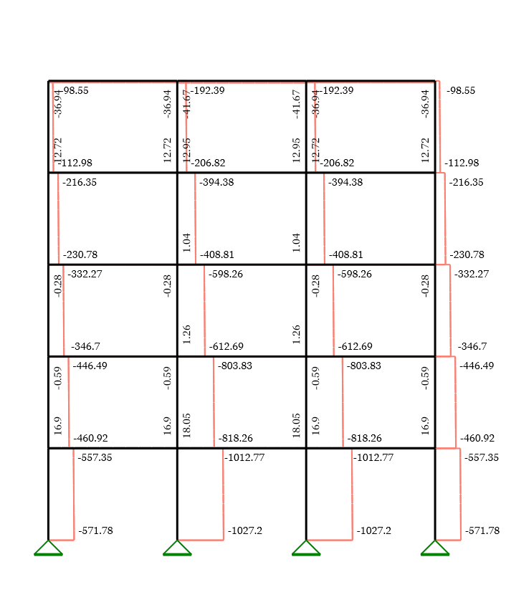
Shear forces diagram, kN
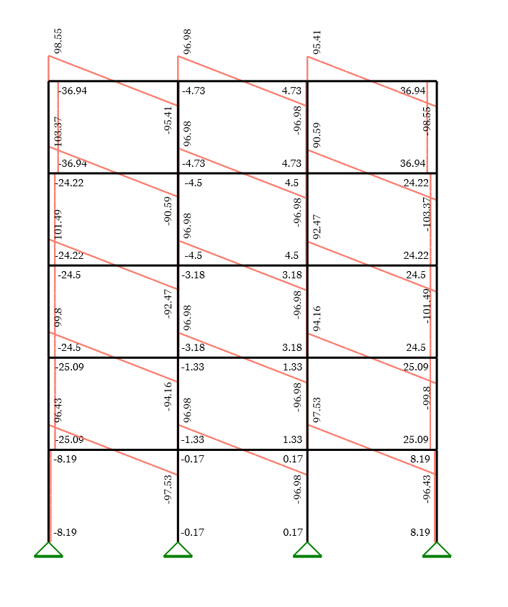

Bending moments diagram, kNm
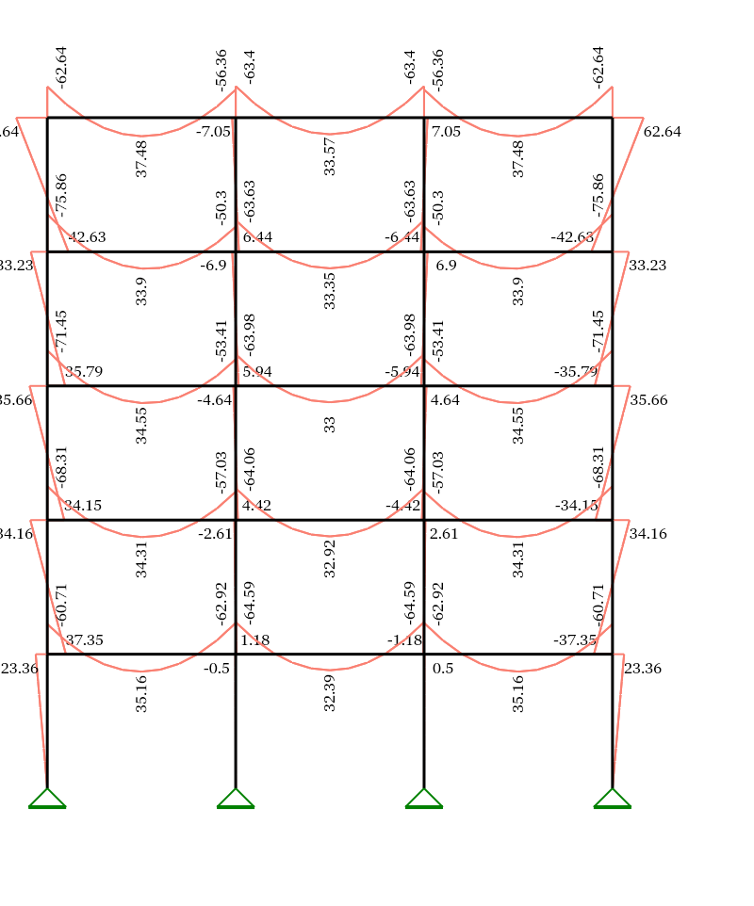
Deformed shape
Shape function in relative coordinates ξ = x/l (with account to shear deflections)
$$Φ_{1}\left(e;ξ\right)=\frac{1}{1+k_{s}\left(e\right)}·\left(1+k_{s}\left(e\right)-k_{s}\left(e\right)·ξ-3·ξ^{2}+2·ξ^{3}\right)$$
$$Φ_{2}\left(e;ξ\right)=\frac{ξ·l\left(e\right)·m^{\text{-}1}}{1+k_{s}\left(e\right)}·\left(1+\frac{k_{s}\left(e\right)}{2}-\left(2+\frac{k_{s}\left(e\right)}{2}\right)·ξ+ξ^{2}\right)$$
$$Φ_{3}\left(e;ξ\right)=\frac{ξ}{1+k_{s}\left(e\right)}·\left(k_{s}\left(e\right)+3·ξ-2·ξ^{2}\right)$$
$$Φ_{4}\left(e;ξ\right)=\frac{ξ·l\left(e\right)·m^{\text{-}1}}{1+k_{s}\left(e\right)}·\left(\frac{\text{-}k_{s}\left(e\right)}{2}-\left(1-\frac{k_{s}\left(e\right)}{2}\right)·ξ+ξ^{2}\right)$$
Element endpoint displacements and rotations
$$z_{E,loc}\left(e\right)=T\left(e\right)·z_{E}\left(e\right)$$
$u_{1}\left(e\right)=\text{take}\left(1;z_{E,loc}\left(e\right)\right)$ , $v_{1}\left(e\right)=\text{take}\left(2;z_{E,loc}\left(e\right)\right)$ , $φ_{1}\left(e\right)=\text{take}\left(3;z_{E,loc}\left(e\right)\right)$
$u_{2}\left(e\right)=\text{take}\left(4;z_{E,loc}\left(e\right)\right)$ , $v_{2}\left(e\right)=\text{take}\left(5;z_{E,loc}\left(e\right)\right)$ , $φ_{2}\left(e\right)=\text{take}\left(6;z_{E,loc}\left(e\right)\right)$
Displacement functions (with account for intermediate loads)
$$u\left(e;ξ\right)=u_{1}\left(e\right)·\left(1-ξ\right)+u_{2}\left(e\right)·ξ+\frac{n_{E}\left(e\right)·\text{m}}{EA\left(e\right)}·ξ·\left(1-ξ\right)$$
$$v\left(e;ξ\right)=v_{1}\left(e\right)·Φ_{1}\left(e;ξ\right)+φ_{1}\left(e\right)·Φ_{2}\left(e;ξ\right)+v_{2}\left(e\right)·Φ_{3}\left(e;ξ\right)+φ_{2}\left(e\right)·Φ_{4}\left(e;ξ\right)+\frac{q_{E}\left(e\right)·{l\left(e\right)}^{4}}{24·EI\left(e\right)}·\frac{ξ^{2}·{\left(1-ξ\right)}^{2}}{\text{ m}}+\frac{q_{E}\left(e\right)·{l\left(e\right)}^{2}}{2·{GA}_{s}\left(e\right)}·\frac{ξ·\left(1-ξ\right)}{\text{ m}}$$
Deformed shape, mm
